**FIN**

(Friend In Need)

**Prepared** **for**

**Dr. -Ing. Nusrat Jahan Lisa, Assistant professor**

**A. K. M. Ahsanul Hoque, Assistant professor**

**Prepared by**

**Lab Section: B2**

**Kh. Rifat Amin, 180204116**

**Fazlay Elahi Safin, 180204119**

**Sanjida Aziz Tonny, 180204122**

**Md Zahidul Haque, 180204136**

**S.M Tasnimul Hasan, 180204142**

**Date: 01/02/2022**



**Ahsanullah University of Science and Technology**

**Department of Computer Science and Engineering**

**Table of Contents**

|  |  |
| --- | --- |
| **Contents** | **Page no** |
| 1. **Use Case Diagram** | 03 |
| 1. **Use Case Narratives** | 04 |
| 1. **User Stories** | 11 |
| 1. **State Diagram** | 12 |
| 1. **Swim Lane Diagram** | 13 |
| 1. **Class Names** | 14 |
| 1. **CRC** | 14 |
| 1. **Class Diagram** | 16 |

1. **Use Case Diagram:**

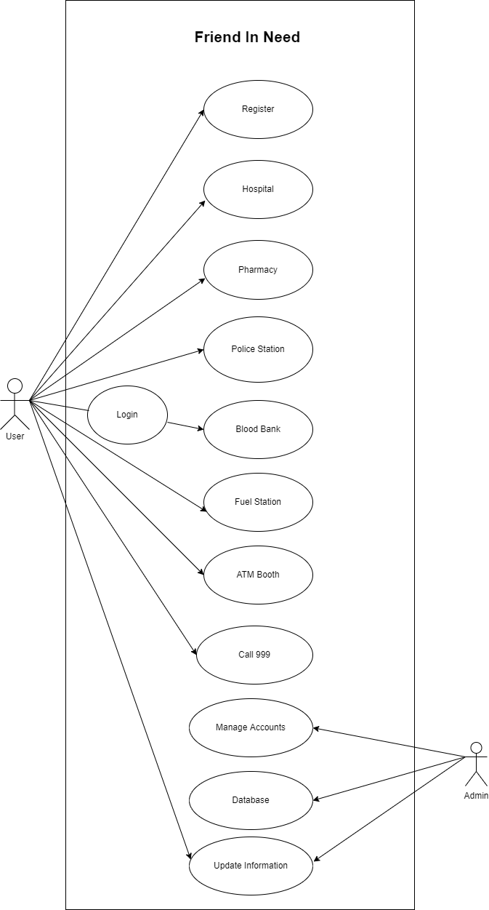

1. **Use Case Narratives:**

|  |  |
| --- | --- |
| **ID:** | 5001 |
| **Title:** | Hospital |
| **Description:** | In this location-based system, our app will use GPS to detect persons live location. Users can find near-by hospitals in any emergency situation |
| **Primary Actor:** | User |
| **Preconditions:** | Android Device, Internet Connection & Login |
| **Postconditions:** | Install/Update google map from play store |
| **Main  Success Scenario:** | Users can find near-by hospitals in any emergency situation at anywhere |
| **Extensions:** | If the user doesn’t have internet connection, he/she will not be able to access this feature |
| **Frequency of Use:** | Always when user need |
| **Status:** | Under Development |
| **Owner:** | S. M. Tasnimul Hasan |
| **Priority:** | High |

|  |  |
| --- | --- |
| **ID:** | 5002 |
| **Title:** | Pharmacy |
| **Description:** | In this location-based system, our app will use GPS to detect persons live location. Users can find near-by pharmacies from anywhere |
| **Primary Actor:** | User |
| **Preconditions:** | Android Device, Internet Connection & Login |
| **Postconditions:** | Install/Update google map from play store |
| **Main  Success Scenario:** | Users can find near-by pharmacies in any emergency situation at anywhere |
| **Extensions:** | If the user doesn’t have internet connection, he/she will not be able to access this feature |
| **Frequency of Use:** | Always when user need |
| **Status:** | Under Development |
| **Owner:** | Sanjida Aziz Tonny |
| **Priority:** | High |

|  |  |
| --- | --- |
| **ID:** | 5003 |
| **Title:** | ATM Booth |
| **Description:** | In this location-based system, our app will use GPS to detect persons live location. Users can find the nearest location of their desired ATM booths |
| **Primary Actor:** | User |
| **Preconditions:** | Android Device, Internet Connection & Login |
| **Postconditions:** | Install/Update google map from play store |
| **Main  Success Scenario:** | Users can find the nearest location of their desired ATM booths at anywhere |
| **Extensions:** | If the user doesn’t have internet connection, he/she will not be able to access this feature |
| **Frequency of Use:** | Always when user need |
| **Status:** | Under Development |
| **Owner:** | Md Zahidul Haque |
| **Priority:** | High |

|  |  |
| --- | --- |
| **ID:** | 5004 |
| **Title:** | Police Station |
| **Description:** | In this location-based system, our app will use GPS to detect persons live location. Users can contact any near-by police station for any emergency need |
| **Primary Actor:** | User |
| **Preconditions:** | Android Device, Internet Connection & Login |
| **Postconditions:** | Install/Update google map from play store |
| **Main  Success Scenario:** | Users can contact any near-by police station for any emergency need at anywhere |
| **Extensions:** | If the user doesn’t have internet connection, he/she will not be able to access this feature |
| **Frequency of Use:** | Always when user need |
| **Status:** | Under Development |
| **Owner:** | Fazlay Elahi Safin |
| **Priority:** | High |

|  |  |
| --- | --- |
| **ID:** | 5005 |
| **Title:** | Fuel Station |
| **Description:** | In this location-based system, our app will use GPS to detect persons live location. Users can search for the nearest location of fuel stations |
| **Primary Actor:** | User |
| **Preconditions:** | Android Device, Internet Connection & Login |
| **Postconditions:** | Install/Update google map from play store |
| **Main  Success Scenario:** | Users can search for the nearest location of fuel stations at anywhere |
| **Extensions:** | If the user doesn’t have internet connection, he/she will not be able to access this feature |
| **Frequency of Use:** | Always when user need |
| **Status:** | Under Development |
| **Owner:** | Fazlay Elahi Safin & Kh Rifat Amin |
| **Priority:** | High |

|  |  |
| --- | --- |
| **ID:** | 5006 |
| **Title:** | Call 999 |
| **Description:** | If the user doesn’t have an active internet connection, then he/she can use government emergency helpline service 999 |
| **Primary Actor:** | User |
| **Preconditions:** | Android Device |
| **Postconditions:** | Install/Update google map from play store |
| **Main  Success Scenario:** | User can use government emergency helpline service 999 when they don’t have internet connection |
| **Extensions:** | None |
| **Frequency of Use:** | Always when user need |
| **Status:** | Under Development |
| **Owner:** | Kh Rifat Amin & Sanjida Aziz Tonny |
| **Priority:** | High |

|  |  |
| --- | --- |
| **ID:** | 5007 |
| **Title:** | Blood Bank |
| **Description:** | Users can locate blood donor according to his need |
| **Primary Actor:** | User |
| **Preconditions:** | Android Device, Internet Connection & Login |
| **Postconditions:** | Install/Update google map from play store |
| **Main  Success Scenario:** | Users can find blood donor in emergency situation |
| **Extensions:** | If the user doesn’t have internet connection, he/she will not be able to access this feature |
| **Frequency of Use:** | Always when user need |
| **Status:** | Under Development |
| **Owner:** | S. M. Tasnimul Hasan & Md Zahidul Haque |
| **Priority:** | High |

1. **User Stories:**

If a situation occurs that a user forgot his user password, there will be a window to reset it by confirming his identity. The application will send the user a verification code in his email id or phone number to confirm his identity and will let him reset the password.

At the time of emergency if a situation occurs that the user can not connect to internet, the application will offer a feature to call any government emergency service like 999 by one click.

If a user in need of emergency blood and can’t connect with any donor for some reason then he can ask for emergency service which will send the desired blood donors a notification of the need of blood.

In any case someone in need of emergency help and could reach his phone, there will be a facility to ask for help though any smart watch.

The application will save the previous shared location of a requester to trace him if the GPS system stops working for any technical issue.

**4. State Diagram:**

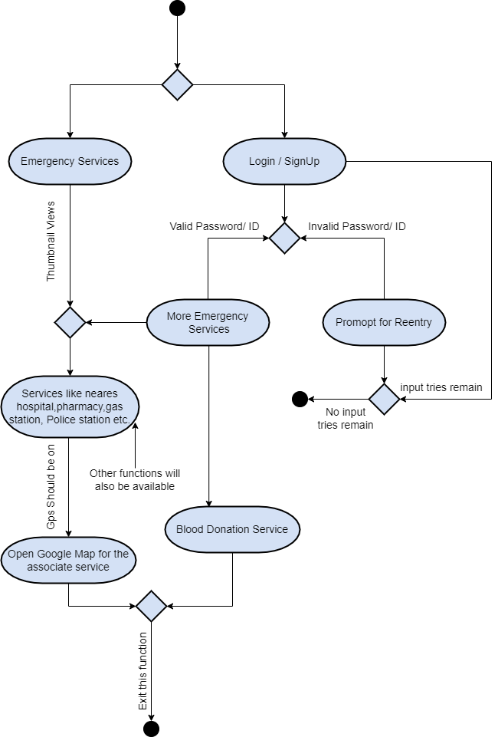

1. **Swim Lane Diagram:**

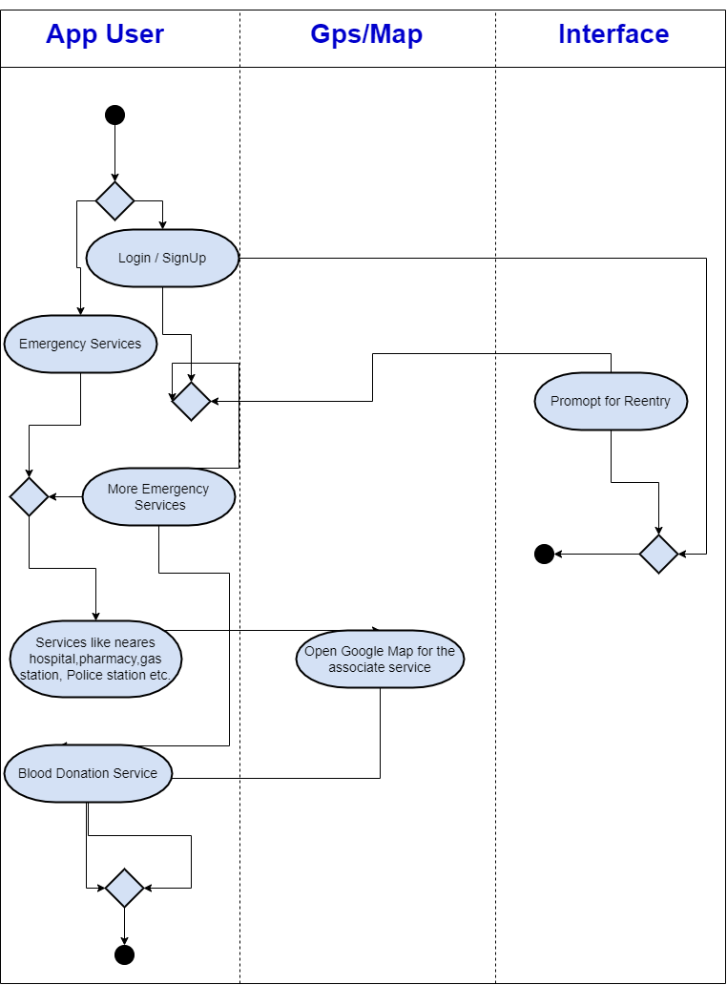

1. **Class Names:**
2. Home
3. Emergency
4. Send Location
5. Login
6. Signup
7. Emergency(logged in)
8. Blood Bank
9. **CRC:**

|  |  |
| --- | --- |
| **Class: Home** | |
| Home page for user after opening the application | |
| **Responsibility:** | **Collaborator:** |
| Creates user interface after opening the app | Emergency |
|
| Shows options of emergency and login | Login |

|  |  |
| --- | --- |
| **Class: Emergency** | |
| Emergency services without login | |
| **Responsibility:** | **Collaborator:** |
| Shows nearby Hospital, Police station, Pharmacy, ATM booth, Fuel station | Send Location |
| Direct Call to 999 |  |
| Shows send location service option |  |

|  |  |
| --- | --- |
| **Class: Send Location** | |
| Sending current location by one tap | |
| **Responsibility:** | **Collaborator:** |
| Choose contact number from phone |  |
| Enter phone number manually |  |
| Get current location and send to selected number |  |

|  |  |
| --- | --- |
| **Class: Login** | |
| User interface for login | |
| **Responsibility:** | **Collaborator:** |
| Takes user input for email and password. | Signup |
| Recovers password if forgotten | Emergency |
| Shows option for creating new account |  |

|  |  |
| --- | --- |
| **Class: Signup** | |
| User interface for login | |
| **Responsibility:** | **Collaborator:** |
| Takes user input for name, email, phone no, location, blood group, password | Login |
| Saves information as blood donor |  |
| Creates new user account |  |

|  |  |
| --- | --- |
| **Class: Emergency(logged in)** | |
| Emergency services logged in users | |
| **Responsibility:** | **Collaborator:** |
| Shows nearby Hospital, Police station, Pharmacy, ATM booth, Fuel station | Send Location |
| Direct Call to 999 | Blood Bank |
| Shows blood bank service option |  |
| Shows send location service option |  |

|  |  |
| --- | --- |
| **Class: Blood bank** | |
| Finding Blood donor from different groups | |
| **Responsibility:** | **Collaborator:** |
| Selects specific blood group |  |
| Shows donors from selected group |  |
| Gives detailed information about donors |  |

1. **Class Diagram:**

